Web Metadata Editor  
*User guide*

The Metadata Editor allows users to describe entities provided by their organization in a standard form accepted and ready to be ingested by EPOS services into the CERIF Metadata Catalogue.

The Editor is available at the following URL: <http://epos.cineca.it/apache/mde/public/index.php>

After loading the page, the user is presented with 2 (3, actually) possibilities: create new file or convert an existing one (Fig.1)

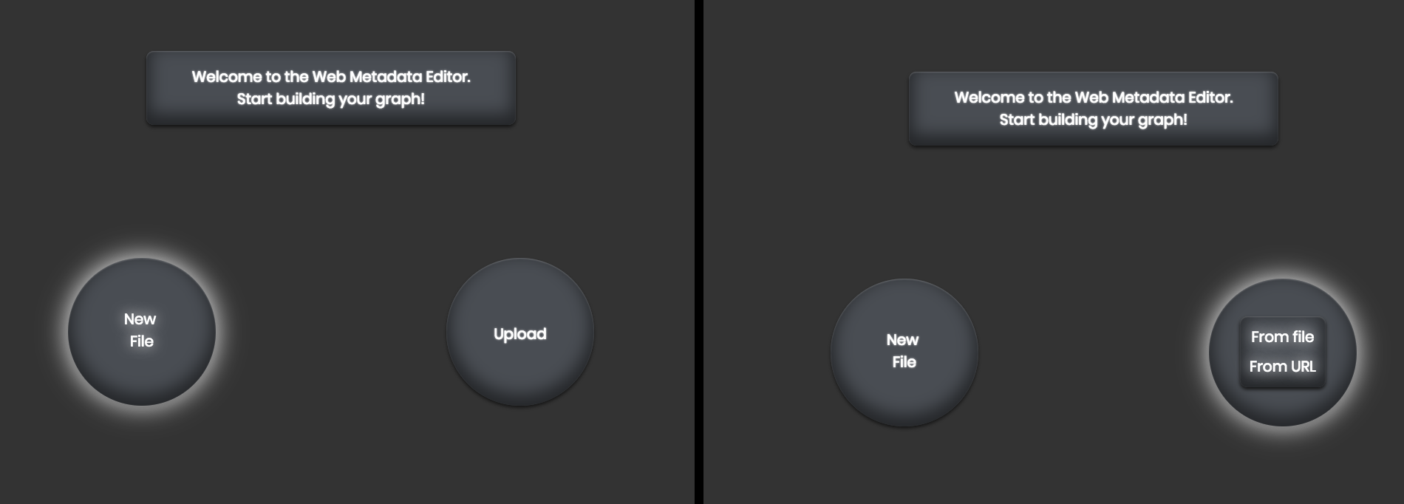

Figure 1: new file / upload one (from file or from URL)

By clicking on “*New File”*, a blank page appears, and the user is given with the possibility to define a new ***Person****,* a new ***Organisation*** or a new ***Webservice*** (Fig.2).



Figure 2: blank screen for new entities

One can create as many entities as he needs. Let’s start for instance from a new Webservice (Fig.3):

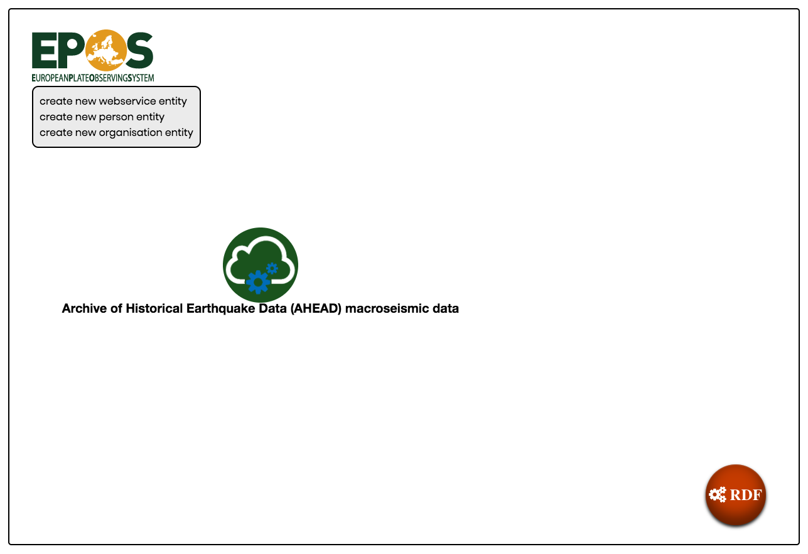

Figure 3: new webservice

The graph starts populating with the defined node. Along with it, by left-clicking on the node, a contextual menu associated with it provides some additional features (Fig.4):

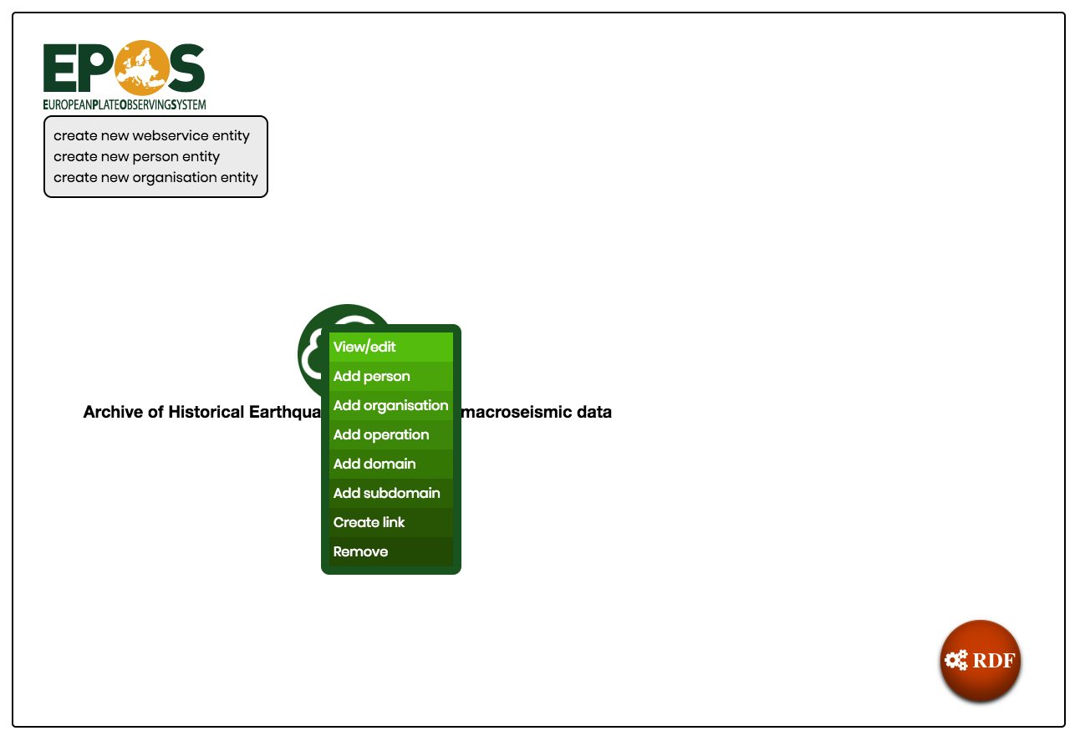

Figure 4: contextual menu

Some of them are common to every entity: view/edit the current node, create a link with any other defined one, remove the current node. Other features are specific to the typology of entity: from Fig. 4 it is possible to notice five *“Add [entity]”* voices (quite self-explaining), of which being *Operation* a new operation entity available for that webservice (defining a new operation it is possible to define parameters as well).

Adding entities leads to a graph populated like shown in Fig.5: 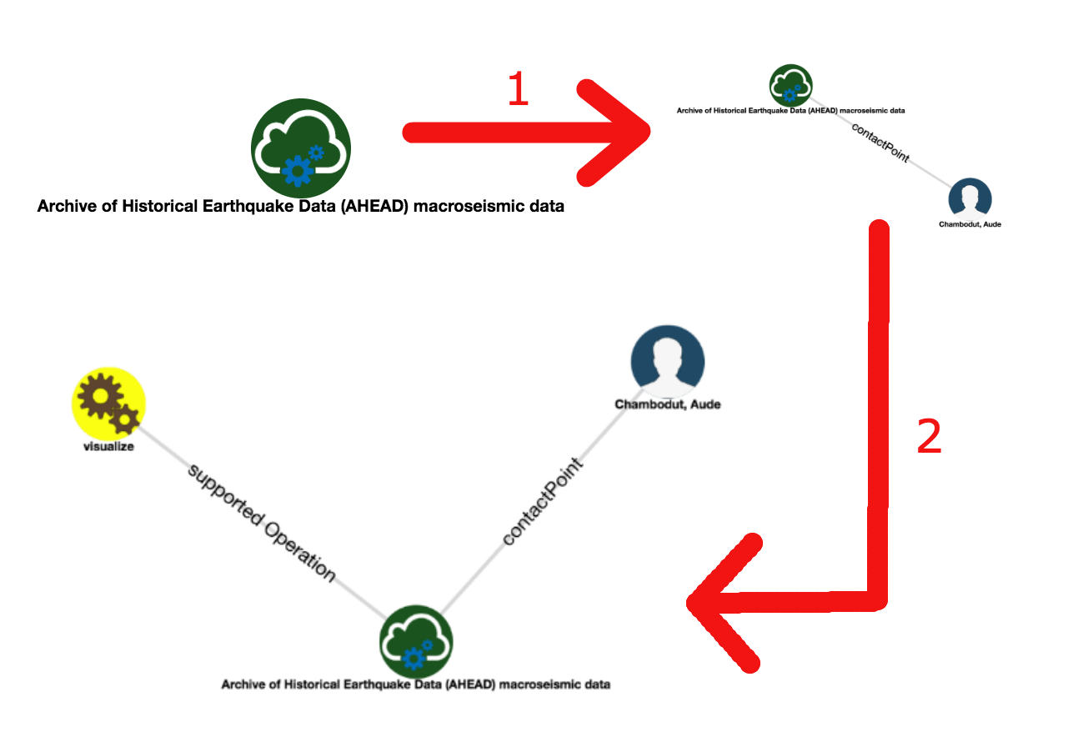

Figure 5: populating graph

One can also define new unlinked entities using the top left menu (Fig.6) and then link it manually to existing entities, using the relative option in the contextual menu (Figs.7-8-9)

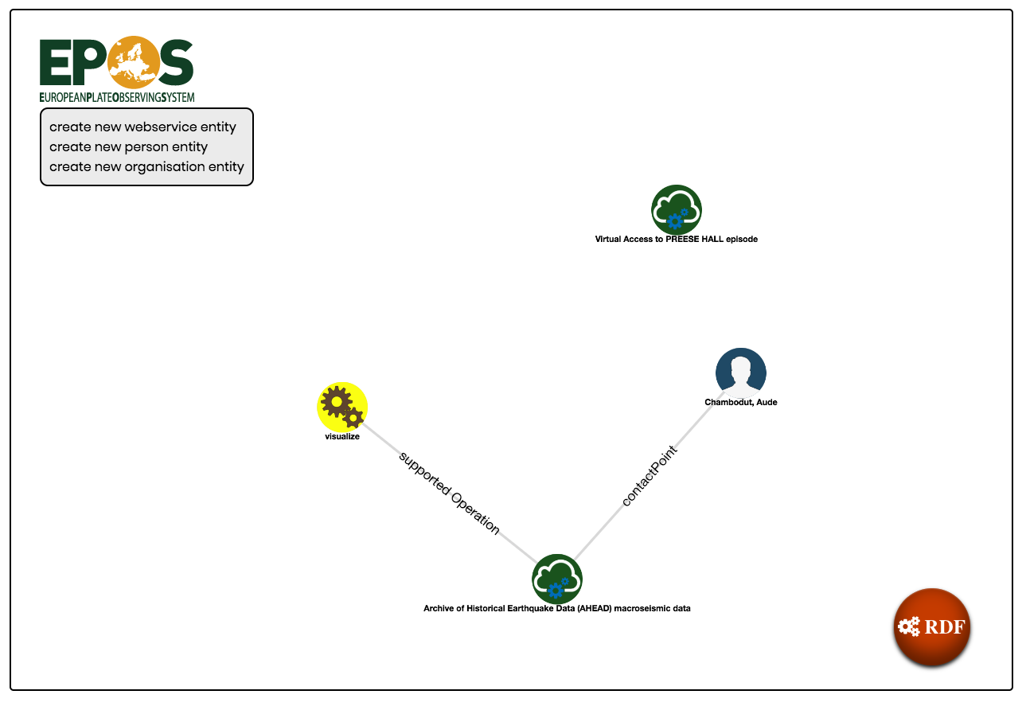

Figure 6: defining new entities

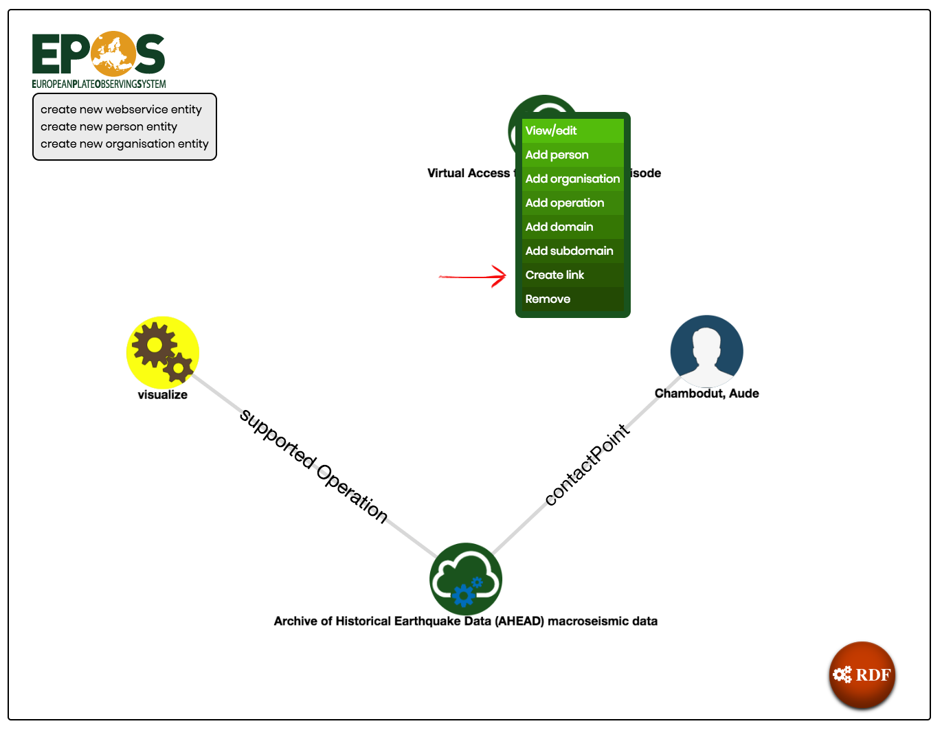

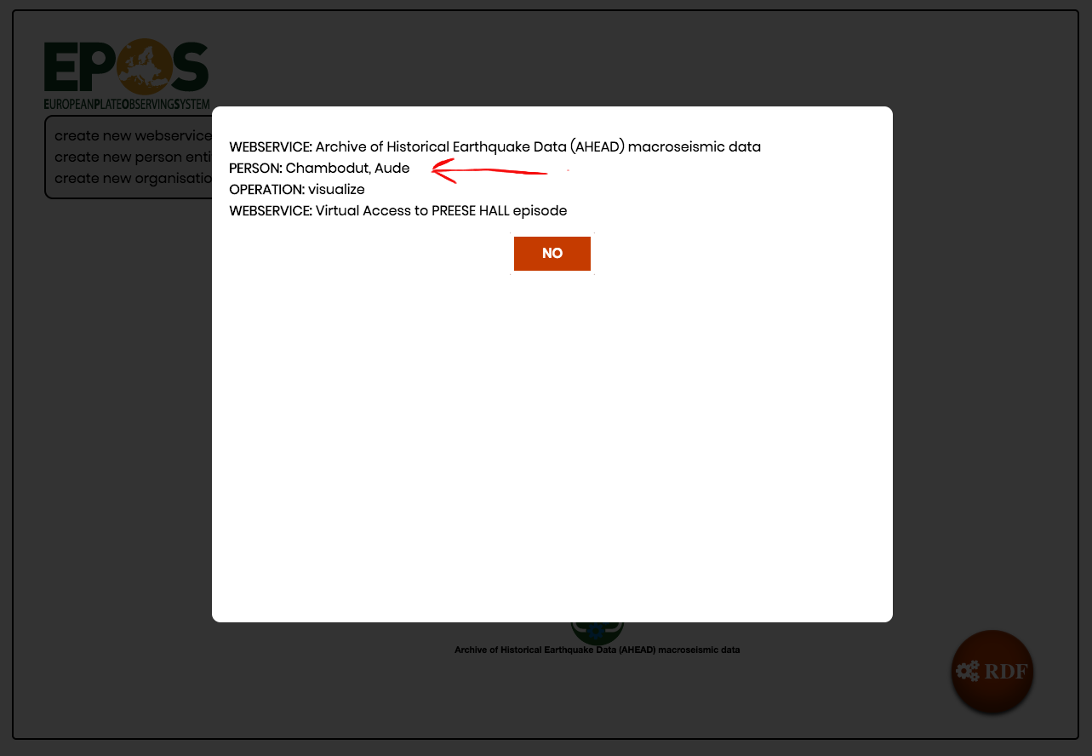

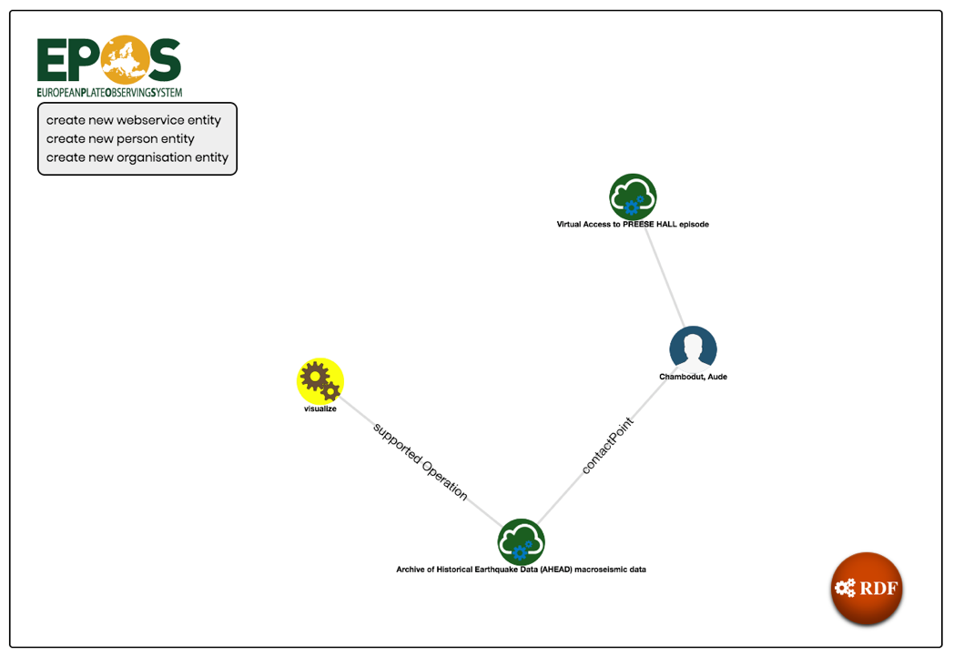

Figure 7-8-9: Create a link between existing entities

Once the user has defined all entities, by clicking on the bottom-right gear (RDF) an overlay pops up, showing a preview of the output EPOS-DCAT-AP RDF file to be sent (Fig.10):

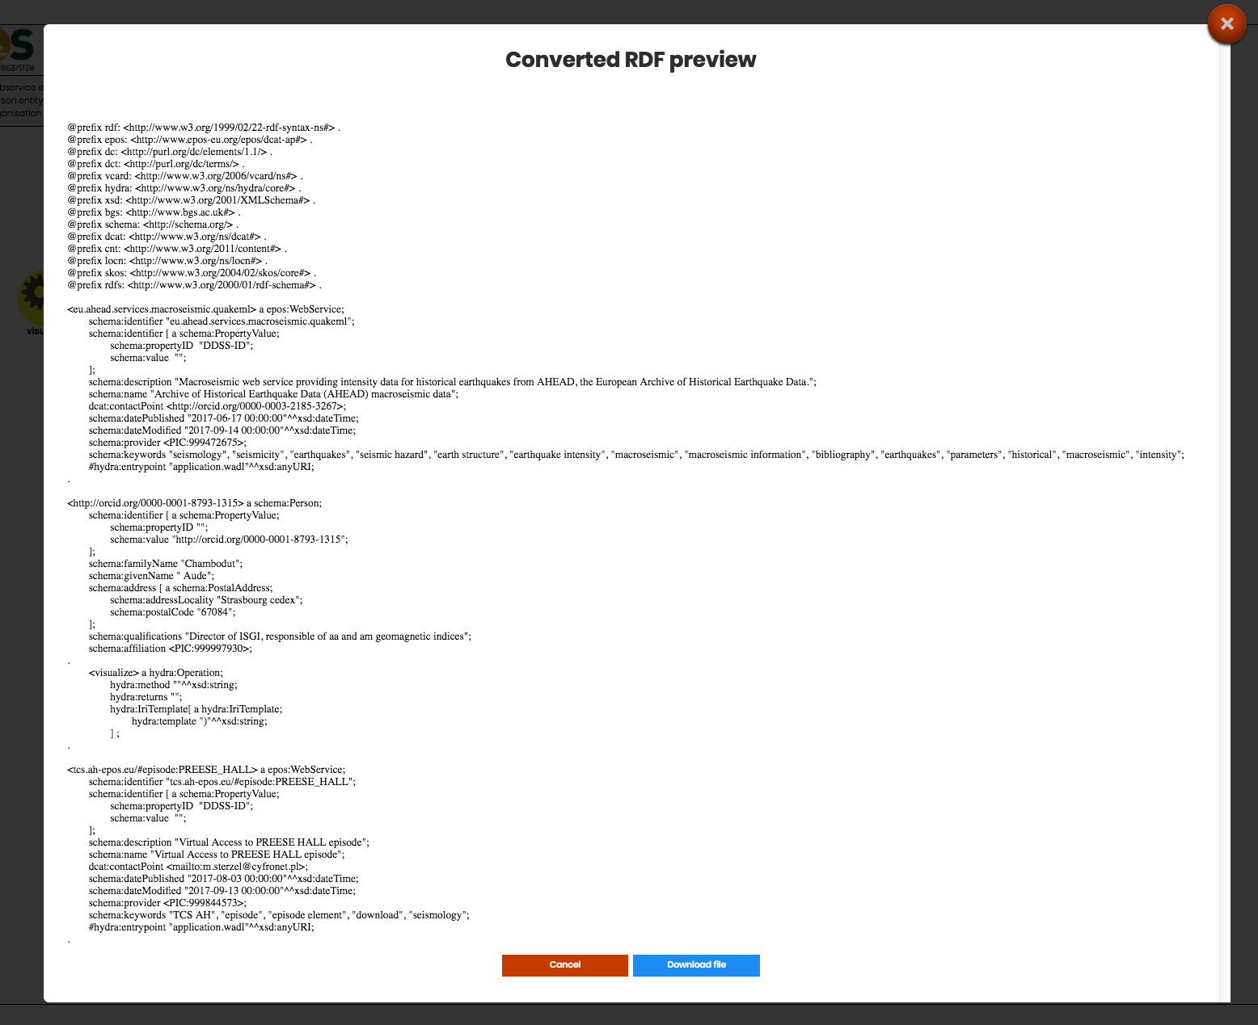

Figure 10: preview RDF

A double choice is presented: a *Cancel* button to go back to the graph (and continue editing) or a *Download file*, to download it and use it to make a pull request on GitHub. Note that the downloaded file can be used to apply further changes before pull requesting, and without passing by the graph.

Going back to Figure 1 and choosing the import option, a user can *Upload from file* or *from URL.* Note that:

- FROM FILE: a file must be an already standard EPOS-DCAT-AP xml file. No different files/formats are handled

- FROM URL: the URL must point to an already standard EPOS-DCAT-AP xml file, not to **a page cointaining** an EPOS-DCAT-AP xml file. So, for instance:

This URL **isn’t** valid:

[*https://github.com/epos-eu/EPOS-DCAT-AP/blob/master/examples/WP08/EPOS-DCAT-AP_WP08_ODC.xml*](https://github.com/epos-eu/EPOS-DCAT-AP/blob/master/examples/WP08/EPOS-DCAT-AP_WP08_ODC.xml)

This URL **is ok:**

<https://raw.githubusercontent.com/epos-eu/EPOS-DCAT-AP/master/examples/WP08/EPOS-DCAT-AP_WP08_ODC.xml>

All the entities contained in the file/URL are exploded and transformed into nodes of the graph (Fig.11):

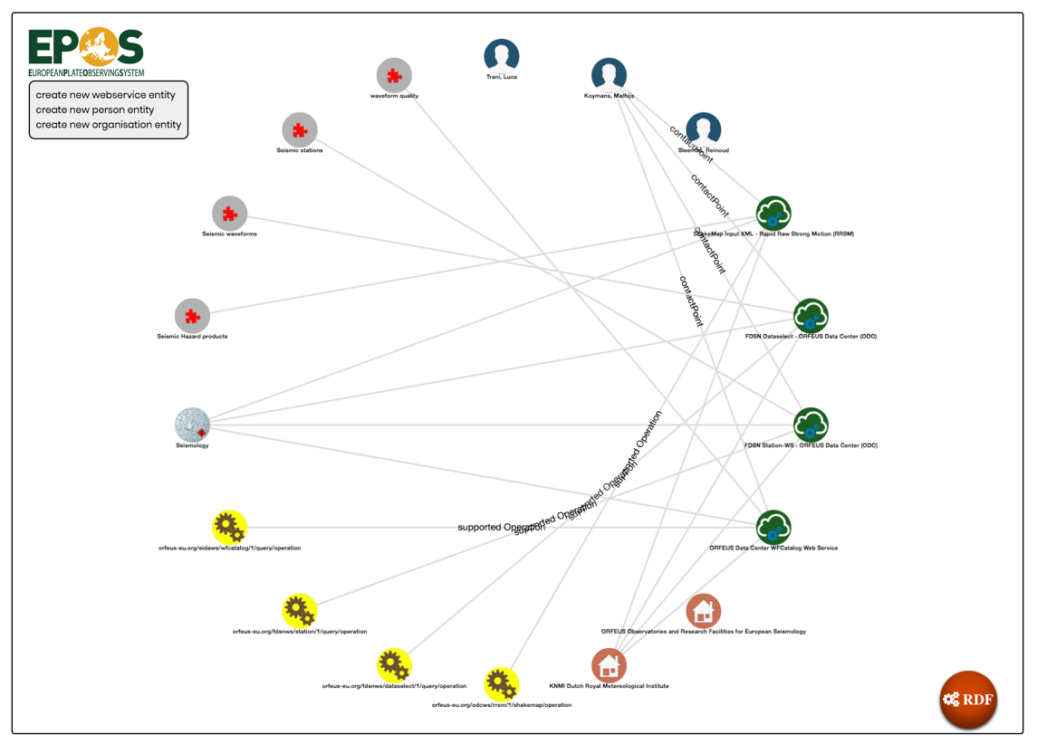

Figure 11: uploaded file

All the options, features, etc. defined before apply to this case.